14. Develop a system using UML for E-Commerce Registration System, to add customers. Then a catalog should be produced for the customer to add items to the cart. The return system should be included, to allow customers to return items within a specific time.

Activity diagram:-

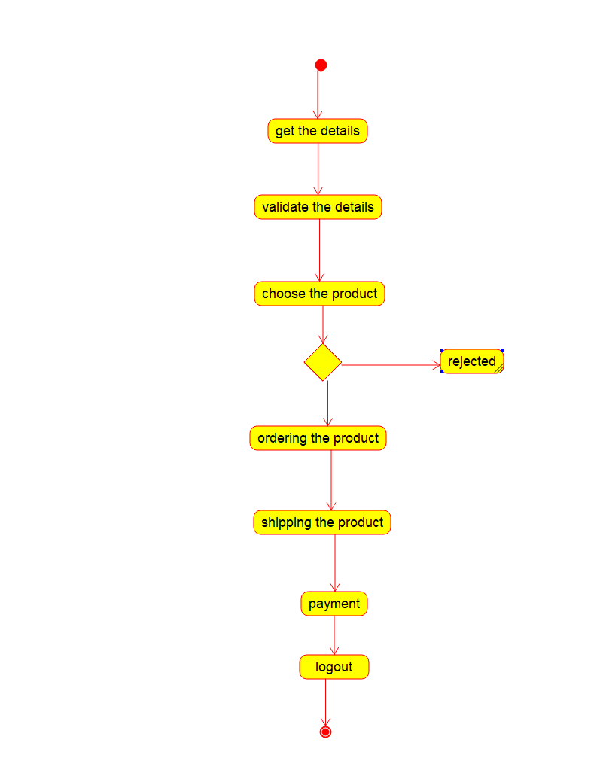

Collaboration diagram :-

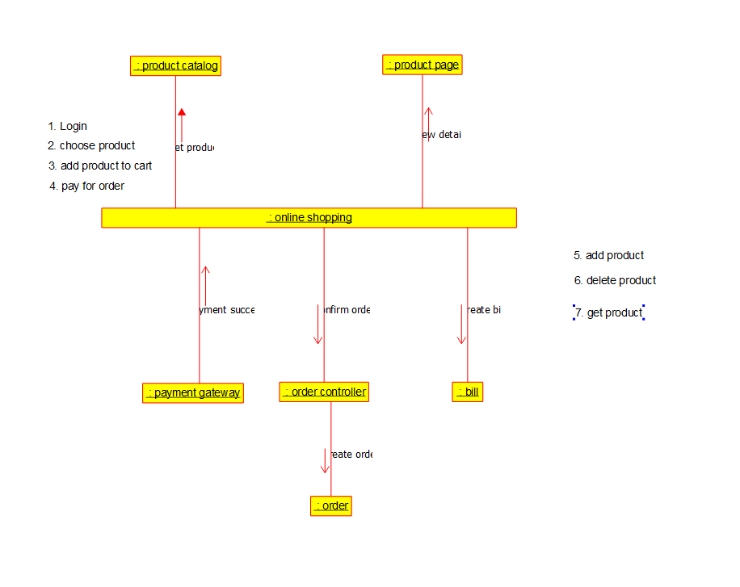

Sequence diagram :-

